**DATA INTEGRATION USING PENTAHO**

**Summary:**

This Project showcases the use of the Pentaho platform for data integration.

**Highlights of actions:**

1. **Loading data sources**
2. Performed cleaning operations on two data sources (Excel and Access DB). Both data sources provide facts for the Fact table of the data warehouse.
3. **ETL Operations**
4. Performed several validations on each field and load validated records into the Fact table of the data warehouse.
5. **Parsed Dates with the Excel Data Source**
6. **Completed Merge Join Orders**

**Screenshots:**

1. Transformation with Excel as source

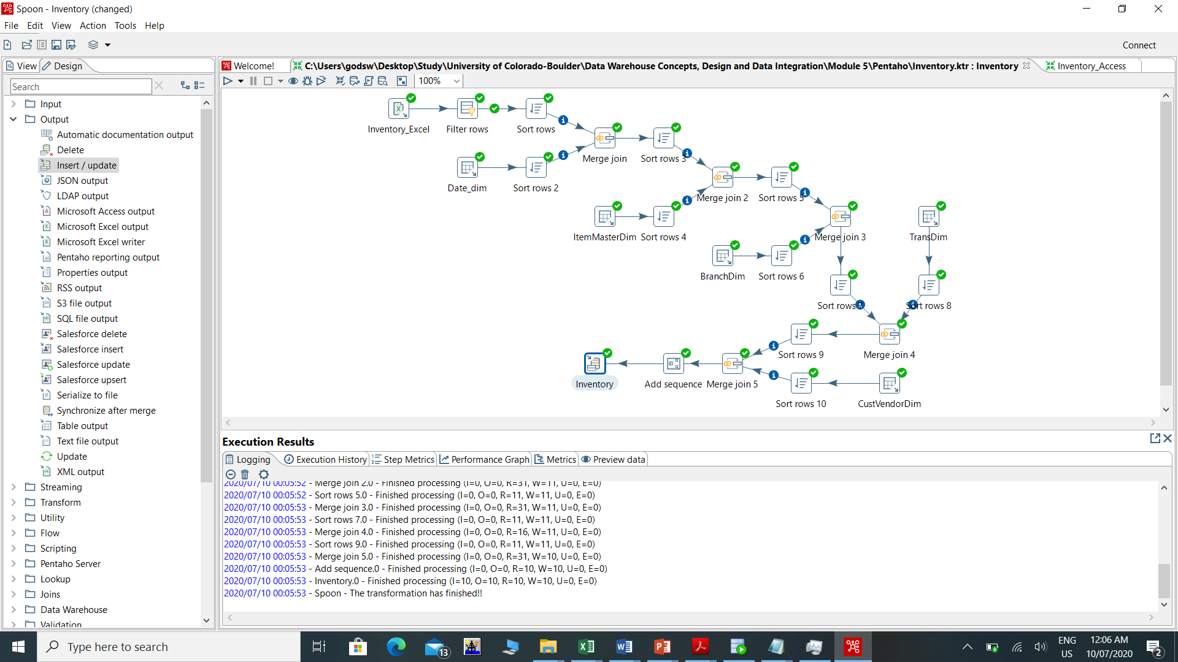

1. Transformation with Access as source

